1ST REMINDER:

Lawn Renovations will begin the week of September 2nd
(weather permitting)

Our regular maintenance schedule will be interrupted for the entire month of September due to the lawn renovation service. We will be off our regular schedule, but we will be there. If for some reason you require your yard to be serviced, please contact our office 516-488-6653.

A lawn renovation consists of power thatching, hand raking/blowing, core aeration and top dress with peat moss or compost. Fertilizer, lime and seed will be applied at this time as per contract. Lawn maintenance will also be performed and billed accordingly.

Please water regularly and continue to water every other day for at least 30-60 minutes per grass section through the end of November, or as needed.

For customers with sprinkler systems if you would like flags to flag your sprinklers, please let us know. Should damage occur during this process, please contact our office and we will dispatch our technicians to repair it. We will not be responsible for repairs performed by another company.

Please contact the office if you have any questions regarding the Lawn Renovations.
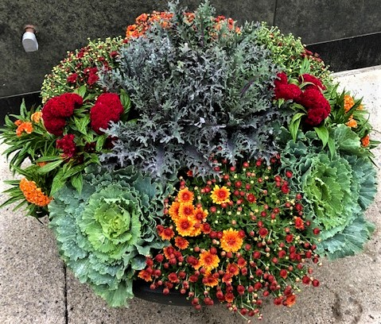
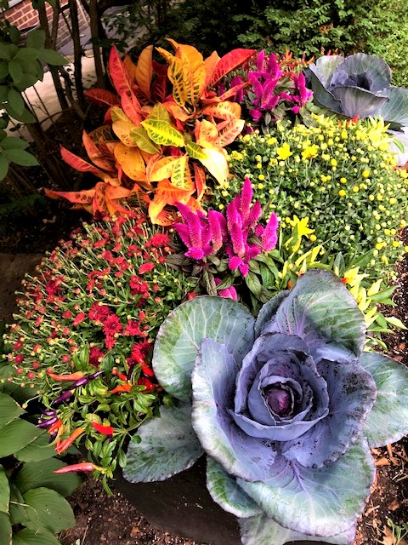
Fall Plantings – The Fall Season is just around the corner. Have your gardens & planters spruced up with some Fall Flair – a fresh crop of Hardy Mums, Cabbage, Kale, Ornamental Peppers, Celosia & more will be available soon! Spring Blooming Bulbs will be available at the end of September. Give us a call to place your order or to set up an appointment with Courtney, our Plant Specialist to plan your Fall Plantings.

Thank you for your business!

Dom’s Landscaping, Inc.
141 Herricks Rd.
Garden City Park, NY 11040
Email: info@domslandscaping.com
Web site www.domslandscaping.com
516-488-6653

